<https://hced.notion.site/Requirement-98eb2a19b1ba40e6a2fd56e283afdf28>

Product Requirement Specification:

* Should not contain redundant requirements.
* In this document, you should define, specify, quantify and justify the engineering.
* Must specify the requirements:
  + Example: “The intervention must be able to lift up to 100 kg.” Here, the phrase “be able to” is redundant and must be removed.

# Table of Contents

1. Weight Configurations (Weight it can carry, weight of the motor)
2. Materials for the Casing
3. Flight Specifications (How should it be able to fly? – Twist --- diagonal)
4. Camera Specifications (Embedded Camera –purpose of the drone itself)
5. Remote Control
6. Power Management

## Weight Configurations

1. Overall weight considerations:
   1. Must lift at least 0.8kg load
   2. Drone itself is a max of 0.5kg
      1. Motors (4x) –
      2. Casing – heaviest component of the drone
         1. Consider 3d printing the casing of the drone
      3. PCB
      4. Antenna(s) must have RX TX capabilities
      5. LiPO battery 6S minimum
      6. Propellers (4x)
      7. Refer to diagram for component break down

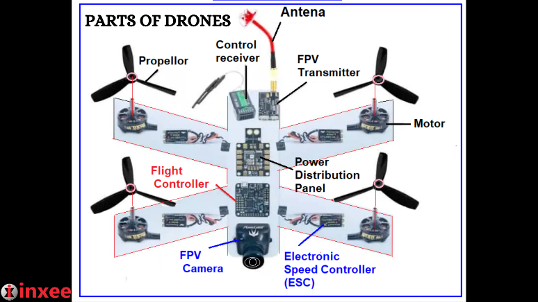

## Materials for the Casing

1. The casing for the overall drone is to be 3D printed.
   1. Polyactic Acid (PLA)
   2. Carbon
   3. PETG

## Camera Specifications

1. Film at 15 FPS (Minimum)
2. Power consumption is minimal
   1. Especially in inactive state
3. Camera transmission should be through wires
   1. [Preferably an SPI camera due to high rates of transmission over short distances](https://www.seeedstudio.com/blog/2019/09/25/uart-vs-i2c-vs-spi-communication-protocols-and-uses/)
4. 720p video quality preferred, but if power consumption gets too crazy, lower quality is okay

## Remote Controls

1. Receiver (RX) antenna on drone does not need to be as strong as the Transceiver (TX) due to data transmission sizes being very different
2. Should have an effective range of 200m
3. Remote controls should be two joysticks, one to control altitude, and another to control direction (magnitude of acceleration changes with respect to joystick position)
4. Video should be displayed either on a separate module or controller itself

## Power Management

1. Battery should be strong enough to support a low KV for motors to support higher loads
2. Module to convert higher voltage power for motors into lower voltage for flight computer, speed and transmission modules to handle
3. Heat build up should be as minimal as possible, but heat sinks are possible
4. Embedded system will be printed on PCB with traces for connections whilst motors will be handled by external wiring hooked up to batteries
5. Electric speed control should be able to remotely control the voltage going into each motor